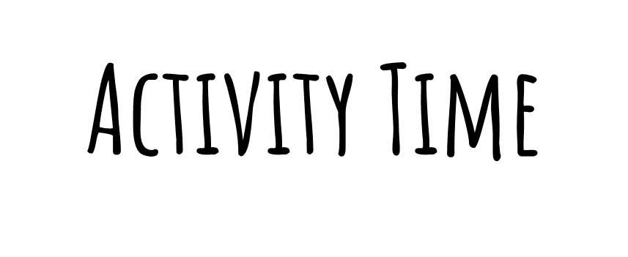

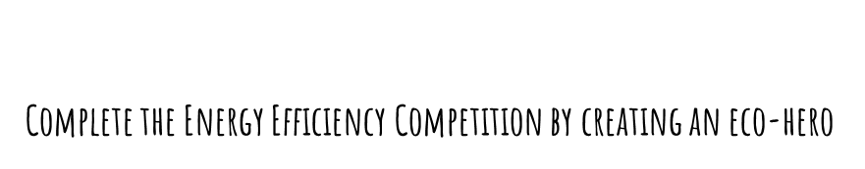

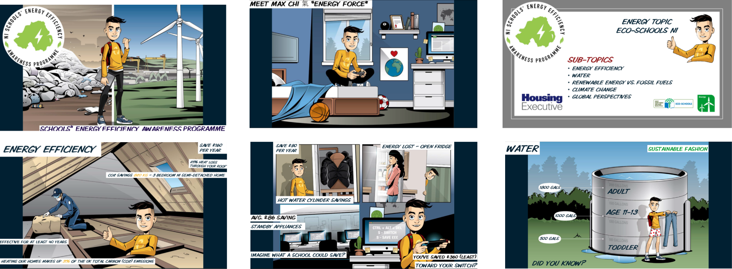

https://www.eco-schoolsni.org/cgi-bin/generic?instanceID=53
https://issuu.com/cowles_g/docs/competition_details_final_2021_-_plus_seeap_pres
