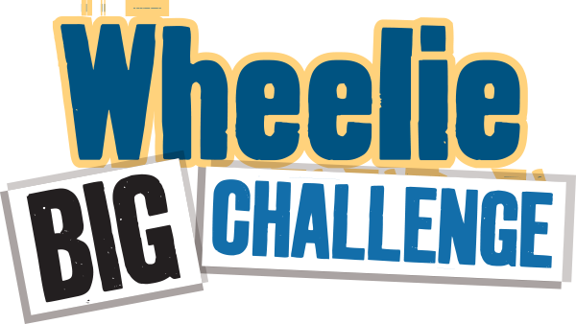
Worksheet – School Waste Audit 1
Simple Audit - What’s happening outside?
Investigate what bin collection system your school is operating. For this activity you will need to access to the area outside the school where your wheelie bins are stored.
How many bins and of what type do you have collected from the school?
(Only count the school’s bins – the canteen bins are usually on a different contract)
 | Waste/Landfill bins | Recycling Bins | Brown/food bins
Size
How many

Bin Size Guide
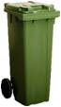  140 litre bin  (standard household bin) | 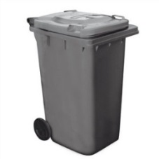  240 litre bin  (standard household bin) | 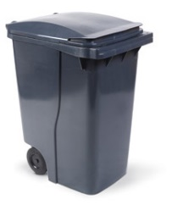  360 litre bin  (deeper than standard household bin) | 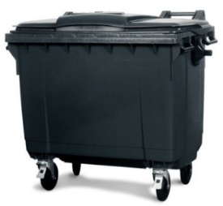  660 litre bin  (midsize - 4 wheels) | 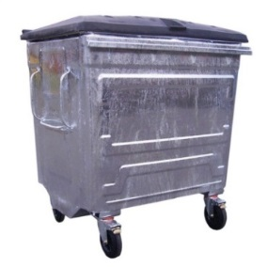  1100 litre bin  (large commercial size bin, metal or plastic)

Who is your Waste Service Provider? (It may say on the bin) ________________________________
How often are they emptied? ________________________________
Take a sneak peek.
What’s in the waste/landfill bins? Can you see recyclable items in there? List any that you see:
____________________________________________________________________________________________________________________________________________________________________________
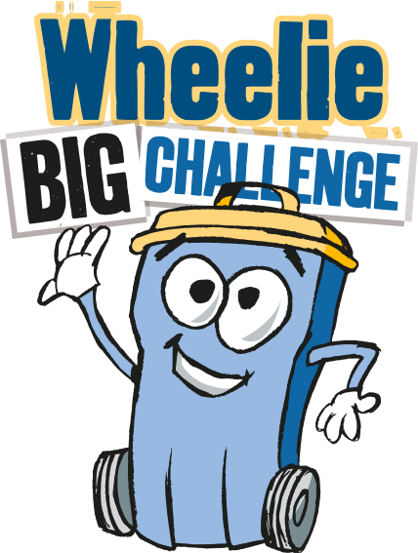
Detailed Audit - What’s happening inside the school?

The aim of this task is find out what is in your waste bins that could be recycled. We are not weighing recycling bins for this task – although you may want to do that separately. You will need gloves, scales and perhaps a plastic sheet for this activity

Choose 5 small waste bins from a variety of areas (e.g. classrooms, office, ITC room, staff room) towards the end of the day. Note you will audit the same bins for Audit 2.
Tip them out, separately, one at a time, onto a floor space that is easy to sweep/clean up – perhaps a plastic sheet would help.
Wearing gloves sort out the rubbish from each bin and using the scales weigh (in grams) each type you find in the table below.
 | Mixed Dry Recyclables  (eg. paper, card, plastic, yoghurt pots, tins) / grams | Compostable Food  (e.g. crusts, fruit, teabags)  / grams | Non-Recyclable  (e.g. wrappers, cling film, pens, straws, tissues)  / grams | Overall weight  (eg. everything in the bin)  / grams
Bin 1 from:

Bin 2 from:

Bin 3 from:

Bin 4 from:

Bin 5 from:

Total weight
Percentage | _________% | _________% | _________% | 100%

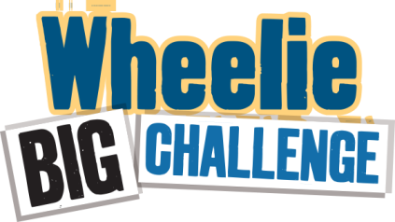
Waste actions
Now that you have done your initial audit it is time for you to consider what you could do to improve the waste situation at your school.
If you have no recycling in place, or you think you could do better, this is a great opportunity to make a massive difference to the school’s environmental record and save some money – remember recycling bins will cost less than waste bins.
If you are an Education Authority controlled school your waste will be managed through them and you should chose a provider from their list: Belfast City Council, Biffa or Bryson.

Your bins are probably already being serviced by one of these companies. Contact them to exchange a waste bin for a recycling bin or to double check what exactly can go into your recycling bins. As time goes on you may find you need more recycling bins than waste bins – think of the money you could be saving!
You could set up composting or a brown bin collection from the school. Belfast City Council are offering a 140 Litre brown bin to schools, with classroom caddies for only £1.87 a weekly lift.
Useful contact numbers for help and advice –
Eco-Schools – 028 9073 6920 eco-schools@keepnorthernirelandbeautiful.org for visits and advice.
Belfast City Council, Waste Education Team – 0800 032 8100 wasteeducation@belfastcity.gov.uk for visits and composting advice.
Belfast City Council Cleansing. Michael Gibson – 07802322892 gibsonmichael@belfastcity.gov.uk for brown bin lifts and internal classroom food caddies.
Education Authority (Belfast) - 028 90 564000 Geoff.Alcorn@belb.co.uk for advice on your waste provider.
Improving things inside the school.
If your audit of inside bins showed that not everything is being recycled as it should be, what can you do to improve the situation? Here are a few ideas –
- Hold an assembly reminding everyone what they need to do and why.
- Improve signage – do people know what goes in which bins?
- Raise awareness through a poster competition.
- Is there a lot of food waste in lunch boxes? Send it home.
- Prizes for the best recyclers – which classrooms pass the sneak peek test?
- Arrange bin monitors in each class to keep everyone right.
- More bins – even labelled boxes would do for paper and plastic recycling.
- Are you filling your waste wheelie bins all the way? You get charged per lift.

